**Effects of the 2012 Michigan Helmet Law on Injury Severity and Crash Population**

Last Four Digits of Student ID: 3641

**Abstract**

In April 13, 2012, Michigan modified its helmet law to allow motorcycle riders over 21 to choose whether or not they want to wear a helmet. Looking at a dataset of Michigan crash data from 2008 to 2012, we analyzed changes in the crash population before and after 2012, showing higher rates of unlicensed motorcycle riders and those not wearing helmets, but no higher rates of out-of-state licensed vehicles crashing, pointing to changes in the crash population. We also used logistic regression to predict whether riders were more likely to be in fatal or incapacitating (KA) accidents given that they were already in the crash population, and significant predictors included not wearing a helmet, being 21 and older, alcohol involvement at the crash level, and being a passenger. We found that motorcycle injuries after the law were more not significantly more likely to be KA in the first year of the law. This lack of change may be attributed to many factors, such as unknown exposure rates, and only having eight months of data after the law was implemented. However, the paired findings that helmet use has decreased after the law and that helmet use significantly impacts injury severity suggest that the effect of the law on injury severity may change with more data.

**Introduction**

As of April 13, 2012, the state of Michigan changed its mandatory motorcycle helmet law. For 40 years before the law change, motorcycle riders were required to wear helmets. However, after April 2012, wearing a helmet was no longer required for riders 21 and older, given that the motorcycle rider has either passed a motorcycle safety course or has carried a motorcycle endorsement for more than two years. In addition, riders foregoing helmets must have at least $20,000 in medical insurance coverage. Riders under 21 are still required to wear helmets.1 The law was passed to boost Michigan's economy by attracting out-of-state tourists.2

Mayrose cites a National Highway Traffic Safety Administration statistic that motorcycle helmets are 65% effective in preventing brain injuries 37% effective in preventing death in a crash. His paper, which studies changes in fatalities in states with mandatory (primary) motorcycle helmet laws, secondary helmet laws, (typically those under 18 are mandated to wear helmets) and no helmet laws. He found that the crash population helmet use does change with law, with those crashing in states with primary laws use a helmet at 84%, those in states with secondary helmet laws wearing helmets at 36.2%, and those without helmet laws wearing helmets at 17.6%. He studied Texas and Arkansas, which both changed their laws from primary to secondary in 1997, and found significance in fatality rates in Texas comparing the two years before and after the law, but significance in both four years after the law. Over a four year period, helmet use dropped 46.5% while fatalities increased by 82.1%. 3 In 2012, preliminary reports have seen increases in average insurance payments on motorcycle injury claims in Michigan.1

As crash data can be difficult to analyze without knowledge of underlying exposure rates, motorcycle registrations in Michigan rose from 269,713 in 2011 to 273,114 in 2012, an increase of 1.3% and estimated mileage based on 3,000 miles also rose by 1.3%.3.4 These statistics seem to support reports that the 2012 riding season was longer, because of nicer weather.5

**Statistical Methods**

First, we undertook a substantial amount of data cleaning in order to start analyzing the data. As the data were available in three different files (at the crash, vehicle, and person levels), we chose to consolidate this information on the individual level. The alcohol involvement variable was available on the crash level, and used in the analysis. In addition, the motorcycle license variable was available at the driver level, and analyzed as well.

In this analysis, two datasets were created, one including all motorcycle injuries, and one of the injured drivers. After the data were merged at the individual level, individuals not on motorcycles were dropped. Next, only May through December crash data were retained. This was done to balance the data to compare between years, as the law was enacted on April 13, 2012. Motorcycle riding follows seasonal trends, as can be seen in Figure 1. Finally, the Motorcycle Injuries dataset was created through dropping individuals missing injury severity data (Killed, Incapacitating Injury, Non-Incapacitating Injury, Possible Injury, and No Injury or KABCO). A Driver dataset was further created, dropping all passengers from the dataset. See Figure 2 for more details.

We conducted chi-squared tests of independence to test for independence between variables of interest and whether the crash occurred before or after the law change. This approaches the question a bit differently, not using the covariates to predict for more severe injuries, but to look at the changing crash population. Seeing how the crash population has changed after the law may provide clues on the types of individuals more likely to be in a crash. Variables analyzed here included: helmet use, age category, in state or out-of-state, and motorcycle license. Since motorcycle license was a variable of interest, the Driver dataset was used. Some association plots were fitted, showing which categories are more responsible for the lack of fit from the independence assumption between the variables.

In addition, we ran a logistic regression, that is, a regression that predicts the probability of being killed or incapacitated (KA) in a crash, for those who were in motorcycle crashes. In order to predict the probability of being KA in a crash, different predictors were tested: including whether or not a helmet was worn, age (21 and over or below 21), whether the person was a passenger or driver, before 2012 and after 2012, whether the vehicle was from Michigan or out-of-state, and whether the driver had a motorcycle license. Since the differences between passengers and drivers were examined, the Motorcycle Injuries dataset was used. Those variables that univariately tested significant or were of interest and increased the fit of the model were included in a final multivariate model. Odds ratios are reported, detailing ratio of the odds of being KA after 2012 and the odds of being KA before 2012.

R Version 3.0.2 was used for modeling and generating figures. Model fit was assessed using likehood ratios and Akaike Information Criterion (AIC).

**Results**

*Population Characteristics*

We whittled down the original population from the original data to produce the population used in our analysis. Some main characteristics are summarized in Table 1.

*Association*

We measured changes in the crash population were measured with a chi-squared test, which showed that out-of-state drivers were not more likely to have crashed in Michigan post-law (p=0.110). Drivers who crashed after the law were more likely to have not worn helmets (p <.001) and more likely to not have their motorcycle license (p<.001), although they were not more likely to have used alcohol (p=0.886).

An association plot between law, injury, and helmet use seems to suggest that helmet use is associated with more injuries before the law and no helmet use is associated with more injuries after the law. The change in this association may be due to the high helmet use before the law (97.6%) versus after the law (73.4%) within the crash population. See Figure 3. Figure 4 shows the associations between age category, motorcycle license, and injury. Those under 21 with motorcycle licenses were associated with lower risks of KA and those under 21 without licenses were more associated with higher risks or BCO. This suggests that, for the under 21 population, having a motorcycle license makes drivers less likely to be in serious accidents.

*Logistic Regression*

The logistic regression, which predicts the probability of being KA among drivers and passengers in crashes, first modeled variable individually, then created a final model. The estimates in odds ratios are shown in table 2. Most notably, whether the crash happened before or after the law was not significant (p=0.164) in predicting KA. In addition, Michigan registration was almost significant, (p=0.084) but possibly because there were few out-of-state riders in the crash population (Michigan licenses made up 94.9% of the crash population), and motorcycle license was not significant (p=0.135). The significant variables helmet use, alcohol involvement, and being a passenger. These variables, along with before or after law variable, were put in a multivariate model. The findings are summarized in table 2, but most notably, those in the crash population after the law were 0.796 times as likely to be in a KA accident. This is supported by Figure 5.

**Conclusions**

The associations conducted seem to suggest that riskier individuals are getting into crashes, as seen by the larger proportion of non-licensed motorcyclists in the post-law crash population. Figure 3 also suggests that the association between helmet use and injury is flipped before and after the law. However, this may be a result of the high rates of helmet use in the pre-law crash population, illustrating that the 2012 association would continue in the future, as helmet use becomes less common.

Though the logistic regression did not yield a significant difference in the probability of being severely injured post-law, the data do show two things. Helmet use decreased significantly (p<0.001) and those who wear helmets in the crash population were 0.592 times as likely to be KA in a crash. Together, these indicate an underlying trend that may be obscured by other factors.

One main limitation of this study is that exposure rates are unknown, that is, the sample we see consists of motorcycle riders who have been in an accident documented by a police report, which occur when there is an injury, fatality, or at least $1,000 in property damage.2 The denominator, consisting of all people who ride motorcycles in Michigan, is unobserved, and this can fluctuate from year to year. Moreover, because the number of crashes must be contextualized within the denominator, our logistic regression only predicts the probability of being KA *given* that the person is already observed in the crash population. While reports indicate that the 2012 riding season was longer than usual, record hot weather could be a reason motorcyclists did not ride as much.

In addition, there is not enough data yet to conclusively measure the effect of the law on the severity of motorcycle helmet law change. Some motorcycle riders may not all be aware of the law yet, as it was only in effect for five months before the end of riding season. In addition, just eight months of data is not enough to notice larger trends in the crash severity. Mayrose only found a significantly different rate in fatalities four years after the law, and suggesting that some time is needed for the effects of the law to be seen in the crash data.3 With the 2012 data showing that 73.4% of the crash population still wore helmets, this is still off from Mayrose's findings that helmet use was overall 36.2% in the crash populations of states with secondary laws.3

In addition, there are general unknowns, such as a changing crash population. Perhaps more risky riders are now attracted to motorcycle riding with the law change, which may explain the larger number of those without licenses in the crash population. We also don't know if the behavior of riders without helmets changes after the law; perhaps they may be more cautious when not wearing helmets, explaining the seemingly protective effect of the law against being KA in a crash.

Another limitation of this study is in its categorization of KA and BCO. An alternative would be to use a model that made use of each of the categories, such as a culmulative logistic model, which was put aside in favor of a more interpretable model.

**Tables and Figures**

Figure 1: Motorcycle Seasonal Trends. This was created using the dataset of all motorcycle riders in accidents, before taking out January-April data. See Figure 2 for more on how the data were created.

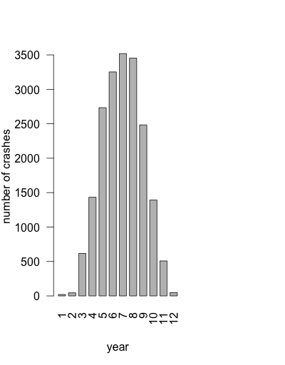

Figure 2: Creating the Motorcycle Injuries dataset and the Driver dataset. The final two datasets used in analysis were the Motorcycle Injuries dataset, to examine differences between drivers and passengers, and the Driver dataset, to examine changes in those who had motorcycle licenses.

**Table 1: Motorcycle Injuries dataset population characteristics (n=16,965)**

|  |  |
| --- | --- |
| **Population Characteristics** | **Mean or Count** |
| **Mean Age** | 41.8 |
| **21 and Over** | 15,262 (92.1%) |
| **21 and Under** | 1,149 (6.78%) |
| **Crash KA** | 3,655 (21.5%) |
| **Crash BCO** | 13,309 (78.5%) |
| **Male** | 14,421 (85.3%) |
| **Year after 2012** | 3,356 (19.8%) |
| **Helmet Worn** | 13,767 (92.5%) |
| **Helmet Not Worn** | 1,112 (7.52%) |
| **Alcohol Involved** | 1,467 (8.65%) |
| **Michigan License** | 15,613 (94.9%) |

Figure 3: Association plots of injury category, before or after the law, and helmet use. The heights of the bars indicate the direction of lack of fit with an independence assumption, which assumes that these three categories are unrelated. We can see that helmet use is more associated with injury before the law and no helmet use is more associated with injury after the law.

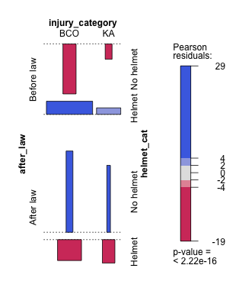

Figure 4: Association plots between injury category, license, and age.

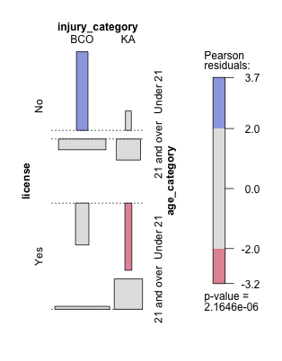

Figure 5: Number of killed or incapacitated (KA) Injuries and BCO injuries in the Motorcycle Injuries dataset across years. KA is in pink and BCO is in blue.

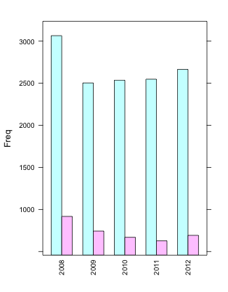

**Table 2: OR and confidence intervals in logistic regression model**

|  |  |  |  |
| --- | --- | --- | --- |
| **Parameter** | **OR** | **95% Confidence Interval** | **p-value** |
| **Univariate associations** |  |  |  |
| After Year 2012 | 0.936 | (0.852, 1.03) | 0.164 |
| Helmet Worn | 0.598 | (0.524, 0.687) | < 0.001 * |
| Alcohol Involved | 3.03 | (2.71, 3.39) | < 0.001* |
| Passenger | 1.40 | (1.24, 1.57) | < 0.001 * |
| Michigan registration | 1.17 | (0.982, 1.34) | 0.084 |
| Motorcycle License | 1.06 | (0.982, 1.14) | 0.135 |
| **Multivariate Model** |  |  |  |
| After Year 2012 | 0.796 | (0.714,0.886) | < 0.001* |
| Helmet Worn | 0.592 | (0.509, 0.688) | < 0.001* |
| Alcohol Involved | 2.95 | (2.61, 3.32) | < 0.001* |
| Passenger | 1.45 | (1.28, 1.64) | < 0.001* |

**References**

1. Highway Loss Data Institute*. Michigan's weakened helmet use law leads to costlier injury claims*. May 30, 2013. http://www.iihs.org/iihs/news/desktopnews/michigans-weakened-helmet-use-law-leads-to-costlier-injury-claims

2. C Flannagan. *Motorcycle Crashes and the Helmet Law Modification in Michigan.* January 22, 2013.

3. J Mayrose. *The Effects of a mandatory motorcycle helmet law on helmet use and injury patterns among motorcyclist fatalities*. Journal of Safety Research 39 (2008) 429-432.

4. Michigan Department of State Police. *2012 Michigan Traffic Crash Facts*. http://publications.michigantrafficcrashfacts.org/2012/2012MTCF_vol1.pdf

5. Detroit Free Press.  *Motorcycle helmet debate keeps revving: Riders, businesses revel in choice in Michigan.*

http://www.freep.com/article/20131211/NEWS06/312110066/motorcycle-helmet-law-fatalities

**Appendix**

We use the logistic model

$$E(logit(π_{KA})) = β_{0}+ β_{1}{YEAR}_{i}+β_{2}{Helmet}_{i}+β_{3}{ALCOHOL}_{i}+ β_{4}{PASSENGER}_{i}$$

**Code Sample**

#total number of crashes seem to generally decrease

t<-table(cvo_mc_month_inj$person_inj,cvo_mc_month_inj$crash_year)

#barchart time

year = c('2008','2009','2010', '2011', '2012')

injury = c('BCO', 'KA')

table = expand.grid(year=year, injury=injury)

count.injury = c(3065,2503,2536,2548,2664,917,743,669,627,692)

table2 = cbind(table, count=count.injury)

barchart(count~year, data=table2, group=injury)

#another way to do it without entering everything

t<-table(cvo_mc_month_inj$person_inj,cvo_mc_month_inj$crash_year, dnn="a", "b")

at <- as.data.frame(t)

barchart(Freq~b, data=at, group=a,scales=list(x=list(rot=90,cex=.8)))

#2008 is a bit of an outlier

#Create assoc plots

license <- driver$Motorcycle_License

injury_category <- driver$inj_cat

age_category <- driver$age_cat

after_law <- driver$year_ind2

helmet_cat <- driver$helmet_cat

d <- data.frame(cbind(license,injury_category,age_category))

d <- data.frame(cbind(helmet_cat,injury_category,age_category))

d <- data.frame(cbind(injury_category,after_law))

d$license <- factor(d$license, labels=c("No", "Yes"))

d$injury_category <- factor(d$injury_category, labels=c("BCO", "KA"))

d$age_category <- factor(d$age_category, labels=c("Under 21", "21 and over"))

d$after_law <- factor(d$after_law, labels=c("Before law", "After law"))

d$helmet_cat <- factor(d$helmet_cat, labels=c("No helmet", "Helmet"))

dtable <- table(d)

#age and injury category

assoc(dtable, shade=TRUE, legend=TRUE, row_vars=license, col_vars=injury_category)

#work with final model glm11

library(aod)

glm11 <- glm(person_inj_cat ~ helmet_cat+age_cat+person_cat+year_ind2+Motorcycle_License, family="binomial", data=cvo_mc_month_inj)

wald.test(b=coef(glm11),Sigma=vcov(glm11), Terms=6)

wald.test(b=coef(glm11),Sigma=vcov(glm11), Terms=5)

cbind(OR = coef(glm11), confint(glm11))

exp(cbind(OR = coef(glm11), confint(glm11)))

#motorcycle license

table(cvo_mc_month_inj$Motorcycle_License)

driver$Motorcycle_License[driver$Motorcycle_License==8]

cvo_mc_month_inj$Motorcycle_License[cvo_mc_month_inj$Motorcycle_License==8]

glm13 <- glm(person_inj_cat ~ Motorcycle_License, family="binomial", data=cvo_mc_month_inj)

#mc license not significant p = 0.135

t2<-table(cvo_mc_month_inj$Motorcycle_License,cvo_mc_month_inj$year_ind2)

t<-table(driver$Motorcycle_License,driver$year_ind2)

t<-table(driver$state,driver$year_ind2)

t<-table(driver$helmet_cat,driver$year_ind2)

t<-table(driver$Driver_Using_Alcohol,driver$year_ind2)

library(vcd)

summary(assocstats(t))

#chisq test is signficiant! more crazy non licensed drivers

t<-table(cvo_mc_month_inj$Motorcycle_License,cvo_mc_month_inj$crash_year)